9 Weeks Test – AP Physics 2

- Which of the following quantities is not a vector?
  - Velocity
  - Electric Field
  - Force
  - Electric Potential
  - Magnetic Field

- A particle has a charge of 2 mC. What is the strength of the electric field 0.2 m from the particle?
  - 450000 N/C
  - 90000 N/C
  - 450 N/C
  - 90 N/C
  - None of the above

- The magnitude of the force on a charged particle is 0.3 N when it is placed in an electric field. If the electric field strength were doubled, and the charge of the particle were halved, the force on the particle would be -
  - 0.075 N
  - 0.15 N
  - 0.3 N
  - 0.6 N
  - It is impossible to tell from the given information.

- A metal sphere has a radius of 0.1 m has a charge of -1.25 C. The magnitude of the electric field at a distance of 0.05 m from the center of the sphere is -
  - 0 N/C
  - 450 N/C
  - 900 N/C
  - 4500 N/C
  - 90000 N/C

- A car starts from a stop and accelerates at a rate of 3 m/s². How far has the car traveled after 5 seconds?
  - 5.477 m
  - 7.5 m
  - 15 m
  - 37.5 m
  - 62.5 m

- Particle A is a positively charged partivle that is held in place. Charge B is a negatively charged particle. As particle B is moved closer to particle A, what happens to the magnitude of the force on particle B and the potential energy of particle B?
Force Potential Energy
  - Increasing Increasing
  - Decreasing Increasing
  - Increasing Decreasing
  - Decreasing Decreasing
  - Decreasing Stays the same

- An electron is placed in a 100 V potential difference. What is the electric potential energy of the electon?
  - 1.6 x 10⁻¹⁹ J
  - 1.6 x 10⁻¹⁷ J
  - 1.44 x 10⁻¹¹ J
  - 3.2 x 10⁻⁶ J
  - none of the above

- Using , and is can be shown . What would an equivalent expression for U_{B}, Magnetic potential energy be?

  - This formula cannot be derived without more information.

- Monica drops a rock off of a bridge. It takes the rock exactly 3.24 seconds to hit the ground. What is the height of the bridge?
  - 15.876 m
  - 21.276 m
  - 31.752 m
  - 51.438 m
  - 504.095 m

- A positively charged particle has a speed of 13 m/s and a charge of 3.2 x 10⁻¹⁹ C. It moves through a region of space where a magnetic field of 0.3 T is directed into the page. What is the magnitude of the magnetic force on the particle?
  - 0 N
  - 3.2 x 10⁻¹⁹ N
  - 1.248 x 10⁻¹⁸ N
  - 1.123 x 10⁻⁸ N
  - This question cannot be answered without more information

B•

- A wire carries current to the right, as shown in the picture. The magnetic field at point B is directed -
  - toward the top of the page
  - toward the bottom of the page
  - into the page
  - out of the page
  - toward the right of the page.

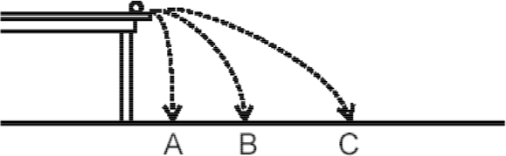

- A ball rolls off a table with several different speeds, as show in the image above. Neglecting air friction, the time between leaving the table and hitting the floor will be greatest for which of the following trajectories?
  - Trajectory A
  - Trajectory B
  - Trajectory C
  - Either A, B, or C, depending on the mass of the ball.
  - The time will be the same for all three paths.

- Capacitance is best defined as -
  - the amount of charge stored in a device per volt of electric potential.
  - the ability to store charge for a certain amount of time
  - the inverse of electrical impedance
  - the strength of the dielectric material inside a capacitors
  - the ability for an electric field to form

- Two capacitors are made from the same mateirals and filled with the same dielectric material. If Capacitor A has plates that are twice the area of capacitor B and the separation of of Capacitor B's plates is one half the separation of capacitor A's plates, which of the following statements relates the capacitance of capacitor A, C_{A} to the capacitance of Capacitor B, C_{B}?
  - 4C_{A} = C_{B}
  - 2C_{A} = C_{B}
  - C_{A} = C_{B}
  - C_{A} = 2C_{B}
  - C_{A} = 4C_{B}

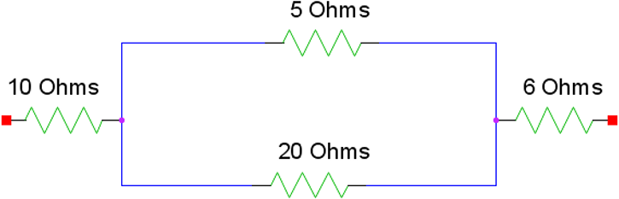
- Current is allowed to flow through the resistor network shown above, from left to right. If the potential difference between the left and right sides of the network is 10V, what is the current that flows through this network?
  - 20 A
  - 10 A
  - 2 A
  - 1 A
  - 0.5 A
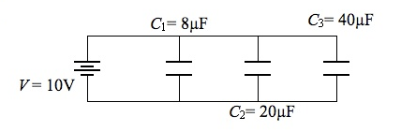
- Three capacitors are wired in parallel, as shown above. What is the equivalent capacitance of the circuit?
  - 5 mF
  - 6.8 mF
  - 12 mF
  - 68 mF
  - 6400 mF

- A car drives 60 miles in 1 hour, then drives 15 miles in 30 minutes. Its average speed is -
  - 30 mph
  - 45 mph
  - 50 mph
  - 55 mph
  - 60 mph

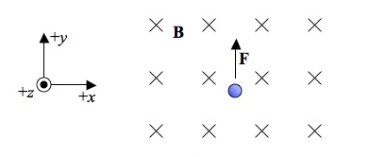
- An electron is traveling though a region of space with a magnetic field in the -z direction, as shown. If the magnetic force due to the field is in the +y direction, the velocity of the particle must be in which direction?
  - +x
  - -x
  - +y
  - -y
  - +z

Ä Ä Ä Ä Ä Ä

Ä Ä Ä Ä Ä Ä

Ä Ä Ä Ä Ä Ä

Ä Ä Ä Ä Ä Ä

- A circular wire of radius 1 m is in a magnetic field that is increasing at a rate of 0.1 T/s into the page. The wire is cut, and a capacitor of C = 1.25 mF is inserted into the loop. What is the amount of charge that will be stored in the capacitor?
  - 0 C
  - 1.265 x 10⁻⁶ C
  - 1.25 x 10⁻⁴ C
  - 3.927 x 10⁻⁴ C
  - 2.1 x 10⁻³ C
In questions 20-22, two answer choices are correct for each quesion. Choose the two answers that are correct. No credit will be awarded for incorrect or partially correct choices.

- The magnetic field a distance of x from a current-carrying wire is 4 mT. A short time later, the magnetic field is -4 mT a distance of 2x from the wire. It can be concluded that the current in the wire -
  - has doubled in magnitude
  - has reversed direction
  - remained the same
  - is increasing at a steady rate
  - is decreasing at a steady rate

- Which of the following statements are true for projectiles?
  - The y-component of the velocity is 0 m/s at the apex of the projectile's trajectory.
  - The x-component of the projectile's velocity is constant throughout the projectile's motion.
  - The acceleration of the projectile is always -9.8 m/s².
  - The time for the projectile to reach the top of its trajectory is always equal to the time it takes the projectile to fall from the top of its trajectory to the ground.
  - A projectile will always follow a hyperbolic path.

- Beauford is chasing Beaulah. He is waddling along at 3.5 m/s, while Beaulah is stumbling forward at 1 m/s. They are separated by a distance of 25 m. Which of the following statements are correct?
  - The distance separating Beauford and Beaulah will always be increasing.
  - Beauford will have to travel 35 m to catch up to Beaulah.
  - Beaulah will walk 25 m before Beauford can catch up.
  - Beauford will catch up to Beaulah in 10 seconds.
  - The time it takes for Beauford to catch up to Beaulah will be different when Beauford and Beaulah compare their watches.

